

**Western Australian Certificate of Education**

**ATAR course examination, 2020**

**Question/Answer Booklet**

12 PHYSICS

Name

**Gravitation and Equilibrium Topic Test**

**Weighting: 4%**

**Mark: /39**

#### Time allowed for this paper forty minutes (40 minutes)

**Structure of this paper**

|  |  |  |  |  |  |
| --- | --- | --- | --- | --- | --- |
| Section | Number of questions available | Number of questions to be answered | Suggested working time  (minutes) | Marks available | Percentage of exam |
| Section One:  Short Answers | - | - | - | - | - |
| Section Two:  Problem-solving | 9 | 9 | 39 | 39 | 100 |
| Section Three:  Comprehension | - | - | - | - | - |
|  |  |  |  | **Total** | 100 |

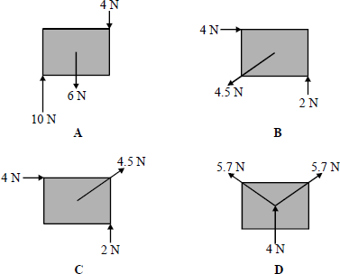**Question 1 [1 mark]**

The rectangular objects, **A**, **B**, **C** and **D** are each 2 cm long and 1 cm high. Which one of the bodies is in static equilibrium?

**Answer: ______________**

**Question 2 [1 mark]**

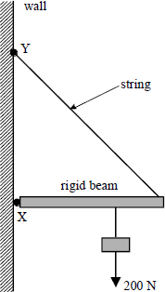In the system shown a light rigid beam, pivoted at **X**, is held in position by a string which is fixed at **Y**. The beam carries a load of 200 N. The load is moved towards **X**.

Which one of the following statements is correct?

|  |  |
| --- | --- |
| **A** | The tension in the string increases |
| **B** | The compression force in the beam increases |
| **C** | The moment of the load about **X** increases |
| **D** | The magnitude of the vertical component of the reaction at **X** increases |

**Answer: ______________**

**Question 3 [1 mark]**

Which one of the following statements about Newton’s law of gravitation is correct?

Newton’s law of gravitation explains

**A**       the origin of gravitational forces.

**B**       why a falling satellite burns up when it enters the Earth’s atmosphere.

**C**       why projectiles maintain a uniform horizontal speed.

**D**       how various factors affect the gravitational force between two particles.

**Answer: ____________**

**Question 4 [3 marks]**

A geosynchronous satellite of mass 520kg is in a constant radius orbit around the Earth. Calculate the height the satellite is orbiting above the Earth’s surface. Show all working.

**Question 5 [8 marks]**

A uniform wooden beam of mass 35.0 kg and length 5.52 m is supported by two identical vertical steel cables **A** and **B** attached at either end, as shown inthe figure below.

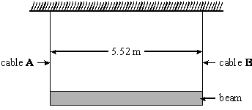

(a)     Calculate

(i)      the weight of the beam

(ii)     the tension in each cable.

**(2)**

(b)     An object of mass 20.0 kg is hung from the beam 1.00 m from cable **A**, as shown in the figure below.

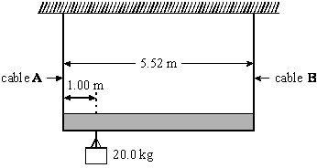

(i)      Calculate the new tension in cable **A**.

(ii)     Calculate the new tension in cable **B**.

**(6)**

**Question 6 [5 marks]**

The diagram below shows a vase placed on a uniform shelf that is supported by a steel wire.

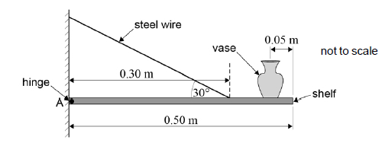

The mass of the vase is 0.65 kg and the mass of the shelf is 2.0 kg. The shelf is hinged at A. The steel wire is attached to the shelf 0.30 m from A and is at an angle of 30° to the shelf. The other end of the steel wire is attached to the wall.

Calculate the magnitude of the tension in the wire.

**Question 7 [6 marks]**

A waiter holds a tray, of mass 0.12kg, horizontally in one hand between fingers and thumb as shown in the diagram.

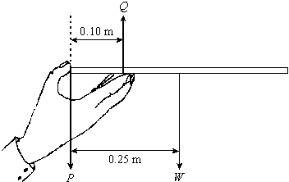

*P*, *Q* and *W* are the three forces acting on the tray.

(a)   Calculate the magnitudes of forces *P* and *Q*.

**(4)**

(b)     The waiter places a glass on the tray. State and explain where the glass should be positioned on the tray if the force, *P*, is to have the same value as in part (a).

___________________________________________________________________

___________________________________________________________________

___________________________________________________________________

___________________________________________________________________

**(2)**

**Question 8 [6 marks]**

(a)    Explain why astronauts in an orbiting space vehicle experience the sensation of weightlessness.

____________________________________________________________________________

____________________________________________________________________________

____________________________________________________________________________

____________________________________________________________________________

____________________________________________________________________________

____________________________________________________________________________

**(2)**

(b)     A space vehicle has a mass of 16 800 kg and is in orbit 900 km above the surface of the Earth.

Calculate the orbital speed of the vehicle.

**(4)**

**Question 9 [8 marks]**

(a)     Derive an expression to show that for satellites in a circular orbit

*T* 2 ∝ *r* 3

where *T* is the period of orbit and *r* is the radius of the orbit. Clearly show all working and assumptions.

**(3)**

(b)     Pluto is a dwarf planet. The mean orbital radius of Pluto around the Sun is 5.91 × 109 km compared to a mean orbital radius of 1.50 × 108 km for the Earth.

Calculate in Earth years the orbital period of Pluto.

orbital period of Pluto = ____________________ yr

**(3)**

(c)     A small mass released from rest just above the surface of Pluto has an acceleration of 0.617 m s–2. Assume Pluto has no atmosphere that could provide any resistance to motion. The radius of Pluto = 1.19 × 106 m. Calculate the mass of Pluto.

mass of Pluto = ____________________ kg

**(2)**